🧠 Mistral AI Content Generator (Flask App)
This project is a web-based content generator powered by Mistral AI. It allows users to generate:
- ✍️ Blog Posts
- 📢 Social Media Content
- 📧 Marketing Emails
- 📊 Slide-wise PowerPoint Presentations

🚀 Features
- Flask-based web interface
- Mistral AI-powered content generation
- Text output and .pptx export
- Supports multiple tones (professional, friendly, persuasive)
- Built-in preview/download functionality

🛠️ Technologies Used
- Python 3.10+
- Flask
- Mistral AI API
- python-dotenv
- python-pptx

📁 Project Structure
``` mistral-ai/ │ ├── app.py # Flask web server ├── mistral_content_creator.py # Core logic: text + ppt generation ├── templates/ │ └── index.html # HTML frontend ├── outputs/ # Generated files (auto-created) ├── .env # API Key (you create this) └── README.md # This file ```

⚙️ Setup Instructions

1. Clone the repo
```bash git clone https://github.com/your-username/mistral-ai-flask.git cd mistral-ai-flask ```

2. Install dependencies
```bash pip install flask python-dotenv python-pptx requests ```

3. Set your Mistral API Key
Create a file named .env in the root folder:
``` MISTRAL_API_KEY=your_actual_mistral_api_key_here ```
🔒 Important: Never share your .env publicly.

4. Run the app

✅ Local (localhost)
```bash python app.py ```
Visit: http://127.0.0.1:5000

✅ On Codeanywhere
Change in app.py: ```python app.run(host=‘0.0.0.0’, port=5000, debug=True) ```
Then use Codeanywhere’s “Open Preview” for port 5000.

✨ Usage
- Enter a topic like: AI in Healthcare
- Choose a content type:
  - blog → Text article
  - social → Tweets/LinkedIn posts
  - email → Short marketing email
  - ppt → Auto-generated PowerPoint content
- Select tone: friendly, professional, or persuasive
- Hit Submit
- View or download the generated content!

📄 Example Output
- Text (blog): Saved as .txt in /outputs
- PowerPoint: Saved as .pptx in /outputs, downloadable

🧪 Sample Prompt for PPT
Topic: Generative AI in Education
Type: ppt
Tone: professional

📌 License
This project is for educational/demo use only. You must have access to Mistral AI to use the API.

🙋‍♀️ Author
Made with ❤️ by Lasya

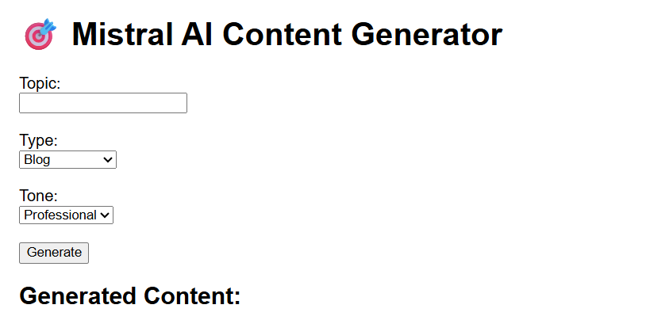
Note: ppt as well as text can be generated
Ppt can be downloaded

